40.32: a) 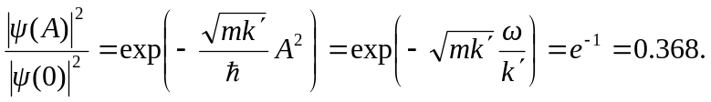
This is more or less what is shown in Fig. (40.19).
b) 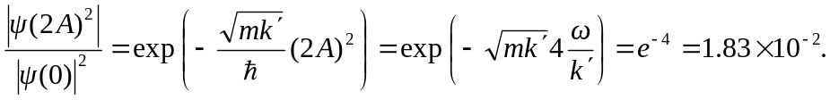
This figure cannot be read this precisely, but the qualitative decrease in amplitude with distance is clear.

